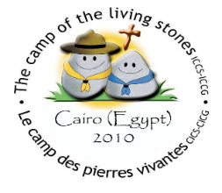

Participant Registration Form Living Stones 04-08.09.2019, Verona, Italy
Name
Sex
Date of Birth
Address
Phone number
E-mail address
Scout/Guide Association
Position
Languages | None | Poor | Can manage | Good | Very good
English
French
Spanish
Other (including mother tongue)
Dietary or other special requirements

Date:
Signature:

Endorsement by IC or Pastoral Committee Responsible:

